[Date]
Gracelin Suresh
[company name]
Literature Review
[Document subtitle]

Introduction:
Retail stores face significant challenges in maintaining accurate shelf inventory since inventory accuracy and operational efficiency represent constant challenges; preventing losses from shoplifting, and mitigating the impact of vandalism. Human related errors can include inaccurate shelf recognition that leads to stock discrepancies, product misplacement, and poor customer experience, while shoplifting and vandalism contribute to substantial financial losses and operational inefficiencies. Our proposed research question is, “How can an autonomous robot effectively address the stores needs, protect store associates and facilities in comparison to a traditional human operator?”.
This literature review will examine different machine learning techniques in computer vision and deep learning algorithms used for product identification, out-of-stock detection, shelf content recognition, and identifying any suspicious activities in the store, all of which are relevant to internal processes in retail stores that range in size from small to large businesses. The efficiency of stock replenishment, counting accuracy, and integrating technology systems that support these procedures are only a few of the major issues that inventory management has historically faced. These issues can be automatically resolved with the help of computer vision and artificial intelligence technology (Kalinov et al., 2020). It has been noted that there aren't enough studies on how to integrate these systems with cutting-edge technologies like the Internet of Things (IoT) to enable even more automated and real-time inventory management (Trung, 2023). While there is much research on image classification using machine learning, few researchers have taken product identification under different viewing angles, blurriness, color, texture, poor lighting conditions and metric sizes(Deng et al., 2013) into consideration. Researchers are becoming more interested in deep learning-based retail product recognition, and a lot of work has been done in this area. The detection of products on the shelf in retail establishments was the subject of only two officially published surveys (Santra B., Mukherjee D. P., 2019), (Melek C. G., Sonmez E. B., Albayrak S., 2017). The authors of a brief study on computer vision-based product recognition in shelf photos were featured in another related survey from (Santra B., Mukherjee D. P., 2019). However, the majority of the techniques offered are based on manually created features, therefore deep learning was not the main emphasis of this survey. Therefore, a fresh thorough survey is required for a better knowledge of this research subject given the growing popularity and prospective uses of deep learning in retail product recognition. Retail establishments are using autonomous monitoring and surveying systems more frequently since they enhance overall store performance and lower labor costs. Marina (2019) reports that ROCKy, a mobile robot for data collection and surveying in a retail store, uses Deep Convolutional Neural Networks (DCNNs) to automatically detect Shelf Out of Stock (SOOS) (Paolanti, M. et al., 2017). ROCKy autonomously navigates and monitors store shelves based on real-time store heat maps. In order to categorize and map SOOS and PA occurrences during business hours, the deep learning method concurrently assesses an image's visual and textual content. In comparison to the current state-of-the-art SOOS and PA monitoring methods, experimental findings demonstrated great accuracy (up to 87%) and a significant decrease in retail surveying time (45%), confirming the efficacy of the methodology. Despite their great significance and success rates, its mobility through the stores along with the customers can pose a threat. Because of its few aisles and sporadic customer traffic, a convenience store's replenishment task is difficult. Thus, it necessitates careful consideration of both consumer safety and the planning, navigation, and control of the robot. Chien-Yu Su (2023) proposed strategies for task and path planning (DWA-PS). A technique for detecting learning objects was proposed by Yedla et al. (2020). FamilyMart in Japan has implemented a replenishment robot system that enables the cashier to restock items using a virtual reality remote control in real-world business applications (Young, n.d, 2020). In the meantime, shelf-scanning robots that can monitor the inventory situation in real time have been installed at Decathlon in San Francisco (Deckathon). Despite these advancements, there is still a need for an autonomous robot replenishment system for a convenience store, particularly efficient methods for planning, navigating, and controlling the robot's course while also taking consumer safety into consideration. Research specifically focused on collision-free path planning in supermarket or convenience store settings has been scarce thus far. Our goals do not cover navigation and planning, but only identification; the above are studies on these fields so far.

Body:
Many studies have focused on the problem of accurate image classification of products on shelves in a store and implementing CNN neural networks through deep learning have been in context of debates and successes among many researchers due to its ease of implementation and approachability(Berg et al., 2013), (Yao et al., 2011).
Theme:
AIMS(Primary): Product Identification, inventory management(counting the stock), Out-of-stock detection, misplaced item on shelves detection.
- Traditional methods:
1.1 Computer Vision for Product Identification:
1.1.1 Feature based Detection:
Bikash (2019) conveys that product recognition poses an exceptional problem for machine learning systems. His paper presents a survey and identifies challenges with this problem. The main problem in inaccurate product identification could be due to small/large sizes, glare, poor lighting, mishap in color or text identification etc. He has implemented deep learning methods for product feature descriptors, these vary from key-point based features which are suitable for image matching, the key points are detected using SIFT(Lowe D.G, 1999), SURF methods(Bay H, et al., 2006). Feature extraction is also adopted with Swin Transformers mainly to differentiate between text and visual characteristics in a product (Jingjing et al., 2023).
Gradient based features
For template-based matching of product photos taken from rack images, gradient-based features (such as the HOG or Sobel operator) are employed. For template matching, product and rack photos' embedded geometric shapes—such as corners or edges—are also used. However, because of unsupervised learning, the performance of simple HOG-like feature implementation is discouraged. For their own publicly accessible dataset, Merler et al. offered three baseline methodologies (Merler, Galleguillos, Belongie 2007 pp.1-8). Their main objective is to solve the recognition problem in which the rack picture (also known as an in situ image) and the product template (also known as an in vitro image) have significantly different qualities. Three different localization strategies are compared. The sliding window-based method is one of them. In this method, the probable product locations (i.e. regions of rack image) are localized by sliding windows of different scales.
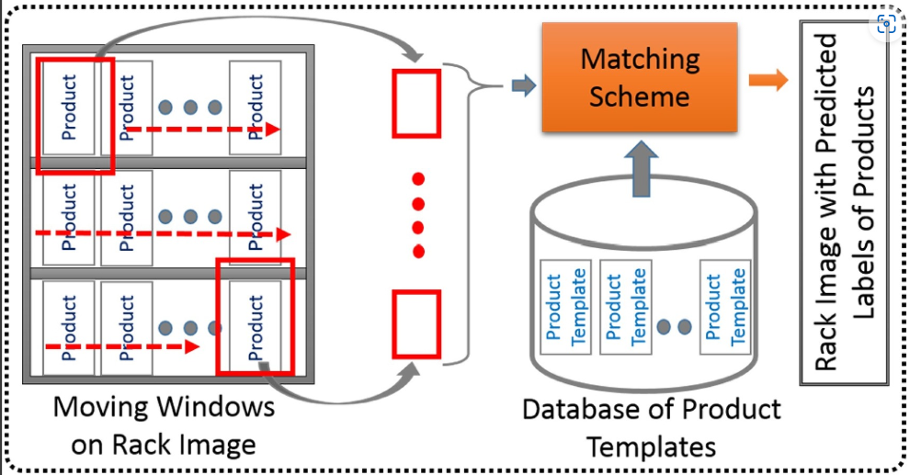
Fig 1. Block diagram of a sliding window based method (Lowe, 1999).

Product localization to locate a particular item among a shelf of images:
This often entails supplying coordinates or bounding boxes for each recognized product in the image. When it's critical to know not only which products are present but also where they are in relation to one another, product localization is a crucial duty. The Unitail-Det (Chen et al., 2022) and SKU-110K (Goldman et al., 2019) databases were specifically designed for product localization. The SKU-110K (Goldman et al., 2019) dataset was utilized by the studies (Goldman et al., 2019, Vararajan et al., 2020, Kant, 2020, Pan et al., 2020, Xu et al., 2022, and Vasanthi and Mohan, 2024) to locate every product on shelf photos. The authors of the study (Goldman et al., 2019) suggest a framework that combines EM-Merger with RetinaNet (Lin et al., 2020), which was created for dense object detection in situations with a large number of products. When compared to the current algorithms described in (Ren et al., 2017), (Lin et al., 2020), and (Redmon and Farhadi, 2017), better performance is obtained. Additionally, the study (Kant, 2020) suggests two distinct models: Gaussian Layer Network (GLN), which has more accuracy and fewer parameters than GDN, and Gaussian Decoder Network (GDN), which is an expanded version of RetinaNet (Lin et al., 2020). In conclusion, the most robust method which yielded higher false positives was the Brute force search and implicit shape model; it is utilized to identify the center points of objects in a specific shelf image. The planogram compliance control algorithm is a modified version of the Needleman-Wunsch algorithm. It is an optimal matching algorithm and alignment technique. For our project, the Swin transformer using CNN methods would be suitable due to its results in multiple overlapping targets, reduced computational consumption.

Methodological Approach:
Swin Transformer Block:
Figure 2 depicts the structure of the Swin Transformer (Z. Liu et al., 2021), a Transformer based on moving windows. The masked patch of image P is the input T^ S−1 of the Swin Transformer block in Figure 1, where LN(.) is the layer normalization function that determines the input image patch's mean and variance in order to preserve the stability of the data's feature distribution. Two fully connected layers make up the MLP(.) layer, which primarily guards against data underfitting. The inpainted masked patch is obtained by adding T S−1 and computing the weighted sum of the masked patch and the nearby unmasked patches using the window-based multihead self-attention (W-MSA) technique. The MLP operation is then applied to T^S to obtain the fitting result T^S. The shifted W-MSA focuses on calculating the relationship between the masked patch and distant patches; the weighted sum of patches plus T^ S is denoted by T^S+1. The MLP operation is performed on T^S+1 and a new masked patch can be generated. 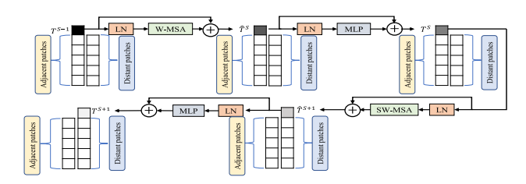

Figure 2: Architecture of the Swin Transformer Block (Z. Liu et al.,“Swin transformer: Hierarchical vision transformer using shifted windows”, 2021)

YOLOX, an high performance object detection system has integrated this transformer into their baseline model (Ge Z et al., 2021) as illustrated in Figure 3.

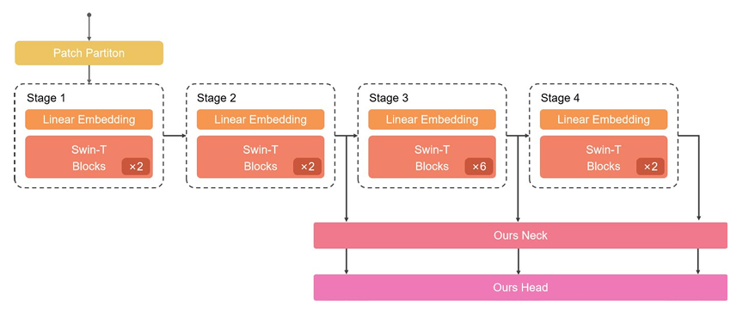
Figure 3: The structure of multi-scale Swin Transformer
Their Dataset
Retail-cabinet dataset:
There are 113 different product categories in the Retail-cabinet dataset, including cookies (like Oreos and baked cakes), beverages (including Sprite, cola, and Assam tea), fast food (such quick noodles and self-heating hot pot), potato chips, egg tarts, and more.
The dataset includes 27583 target objects from 5422 photos (shown in Fig. 4) taken inside intelligent retail cabinets from different positions and angles. During the initial stage, the dataset was split into three sets with a 7:2:1 ratio: training, validation, and testing sets. During training, this tactic made it easier to evaluate and improve the model effectively.
Table 1: Depicts the training, testing and valid data obtained
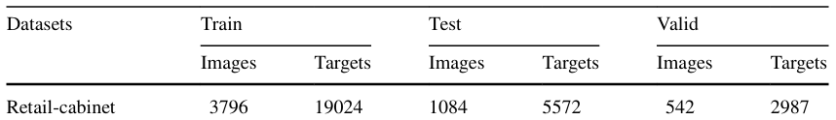
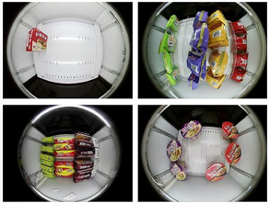
Figure 4: Retail-cabinet dataset
Table 2: Represents the Experimental results of integrated Swin Transformer
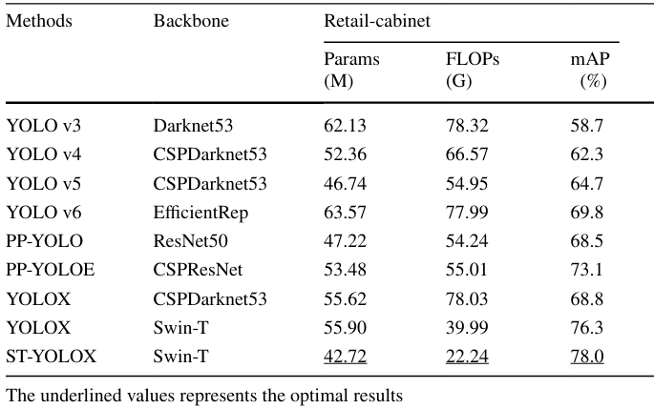
PARAMS, FLOPS and mAP are evaluation metrics to analyze our proposed model compared to other state-of-art methods.
The suggested approach, which incorporates the Swin Transformer, performs better than other cutting-edge techniques on other datasets as well, according to the experimental results shown in Table 2. Our approach provides exceptional detection precision on the difficult Retail-cabinet dataset, which has pictures with several overlapping objects.
Combination of advanced robotics and computer vision for shelf analytics in a retail store:
Dr.Gopichand Agnihotram (2017) proposed a double Robot to patrol the store to address issues such as stock-out and misplaced products. Figure 4, 5 gives the outer architecture. Product classification was experimented using Gradient based features (HOG and SVM) and Deep learning using a Convolutional Neural Network (CNN).

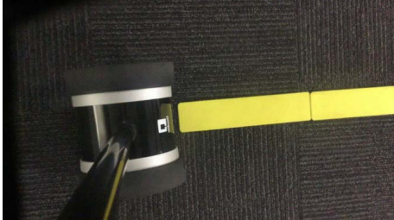
Figure 5: Driver View (Agnihotram G. et al, 2017).
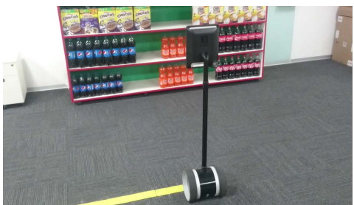
Figure 6: Capturing image of the shelf (Agnihotram G. et al, 2017).
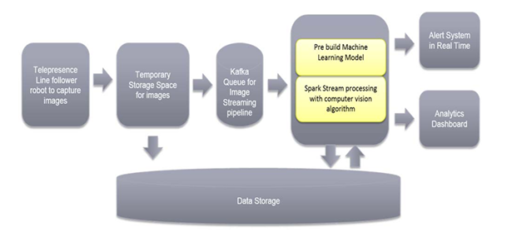
Figure 7: System Architecture (Agnihotram G. et al, 2017).

Machine Learning – Using Hog and SVM
Before HOG feature extraction, each image was scaled to 32x32 pixels. Multiclass support vector machines (SVMs) were used to train the feature vectors and product labels(Viola P. and Jones M, 2004).

Figure 8: HOG like visualization.
Image correction and Noise Removal:
As emphasized before for the problem of blurriness, since the robot is in motion and noise is expected, he has used de-convolution of the image. In order to de-blur the image, a blind deconvolution deblurring technique is used, in which the level of blur is first determined by calculating an impulse response or point spread function(Rafael C et al, 2009). By using this determined function to deconvolute the image, the blur is removed. Similarly, the peak signal to noise ratio (PSNR) is calculated and the high noise regions are suppressed to remove any potential noise from the image.
Results:
As illustrated in Figure 7, the system architecture worked well with the interface solving the problem of out of stock problems and misplaced items. Even with the pros, our analysis would be that this system can have high computation and power cost since the tab fixed must always be “ON”. In a crowded setting the robot can hit customers and cause safety concerns.
Table 3: Testing Results–Comparison
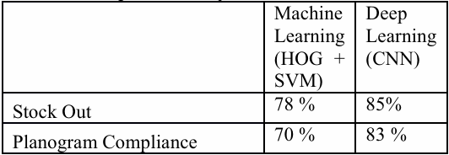
It has been found through testing that applying deep learning algorithms improves the classification accuracy of the product.
Enhanced Out-of-Stock Detection in Retail Shelf Images Based on DeepLearning
Marina(2019) proposed an autonomous Robot for gathering information and conducting surveys in a retail establishment that uses real-time shop heat maps to guide its autonomous navigation and keep an eye on its inventory; ROCKy uses Deep Convolutional Neural Networks to automatically identify and Shelf Out of Stock (SOOS) based on Deep Convolutional Neural Networks (DCNNs). UWB technology and RGB-D cameras are currently the two methods used in an intelligent retail environment to track the behavior and movements of the customers. When it comes to precision, dependability, system cost, and other factors, UWB technology is thought to be the most promising option for indoor tracking(Paolanti M. et al., 2017), this can be used to track customer misconduct through the store, shoplifting attempts etc. The UWB-enabled system may detect customer movement within stores and transmit tracking information to a cloud server. Nonetheless, a number of studies have suggested using RGB-D cameras to study how customers behave in front of a shelf (Mancini A. et al., 2013), (Linciotti D et al., 2017).
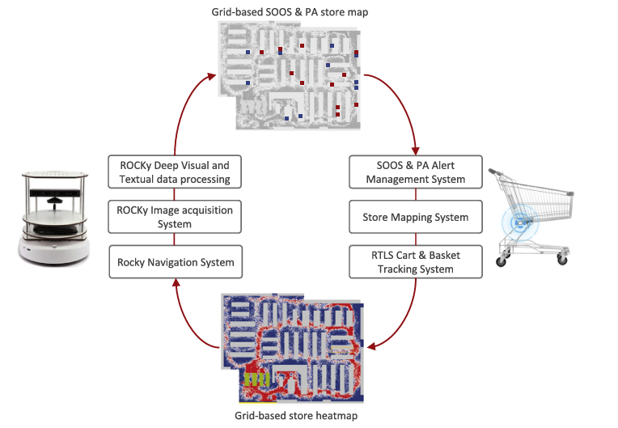
Figure 9: Deep learning visual and textual analysis workflow.
The navigation system is a UWB-based consumer cart tracking device. The cart tracking system indicates that each shopping cart trajectory's Extended Kalman Filter (EKF) is followed by the shopping carts' locations on a grid-based heat map (the grid's size are 30 cm by 30 cm). A six-hour period was selected before a robotic store survey was conducted in each of our tests. Over a predetermined time period, the resulting heat map is normalized between 0 and 100.
Fusion classifier
The fusion classifier uses both textual and visual information to estimate an image's total content. Therefore, the machine learning model was tested with indicated the overall category of the images, and the visual and textual data retrieved from DCNN were pooled in the prediction vector.Six state-of-the-art classifiers were tested based on all features in order to identify the general content of the images: k-NearestNeighbor (kNN), Support Vector Machine (SVM), Decision Tree (DT), Random Forest (RF), Naive Bayes (NB), and Artificial Neural Network (ANN).
Table 4: Number of features
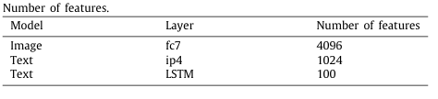
SMARTdataset
The SMART Dataset, a visual and textual retail dataset composed of images that ROCKy obtained throughout many experiments at various stores, is used to thoroughly analyze the framework. There are 14.244 shelf images in the SMART dataset. These photographs fall into three categories, as previously mentioned:
•4748 SOOS images: photographs of SOOS (incorrect scenario with high priority).
•4748 Normal images: Planograms in a typical arrangement (proper scenario).
Results:
In order to account for all possible combinations of overall, visual, and textual annotations, the considered dataset is divided into two randomly selected sub-sets: 80% for training photos and 20% for test images. High precision and recall values can be attained, as demonstrated above, particularly for images with normal and promotional visual content. Visual recognition of SOOS images is more challenging because there is less training data available. Our previous approach of advanced Robotics can be used instead of this.
Table 5:
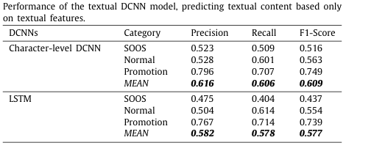
Ego-centric Vision on Shopping carts:
In this paper, they have focussed on solving the problem of Out-of-Stock (OOS) detection from the egocentric perspective, which is simply collecting data-sets (images or videos) using camera vision fitted in the trolleys. They have trained a convolutional Neural Network(CNN) to predict attention maps useful to find OOS in retail areas and suggest to the retail employers where to intervene. They have concluded that this method is promising to help the refiling process in the retail domain.
They have used the publicly available data-cart set containing images on shelves and racks in the retail environment (E. Spera et al. 2019).
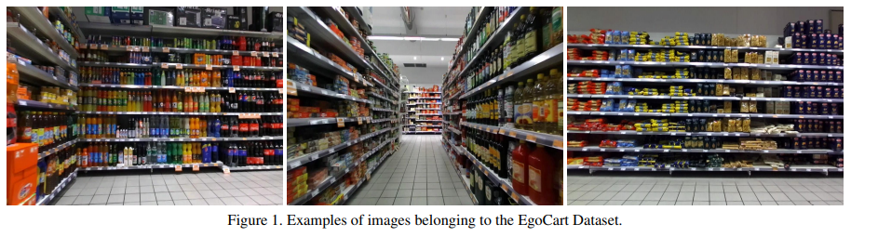
Fig 10. Examples of images belonging to the EgoCart Dataset (E. Spera et al. 2019).
Related works in relation to OOS Detection:
In (J. Chen, S. Wang, H. Lin, 2019) the authors proposed an Out-Of-Stock detection system which consists of two phases: in the first phase, the objects in the shelves were identified by using Faster RCNN (S. Ren et al. 2015) detector; in the second phase, authors employed classical descriptors based on Canny edge detector, grey level co-occurrence matrix and colour features to perform the actual OOS detection.
Methodology:
To consider the problem of OOS they have manually re-annotated the EgoCart Dataset. They used a weak annotation procedure for labeling each OOS, wIth approximate position of its center (Figure 5).
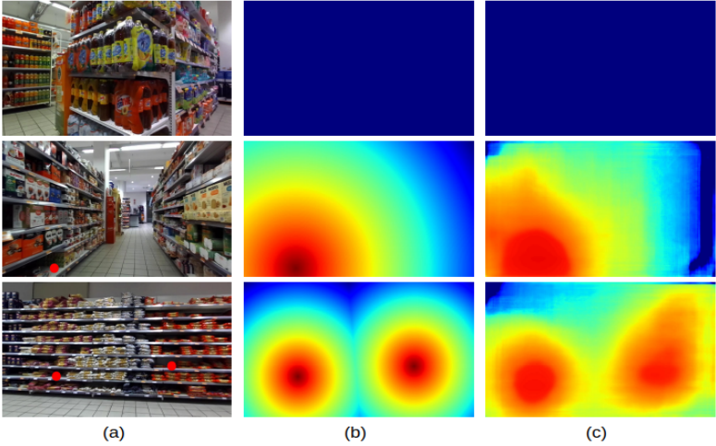
Figure 11: (a) Images annotated with OOS areas (red points); (b) Ground truth attention maps obtained using distance transform; © Predicted attention maps using the proposed approach.

We describe the approach used to benchmark the task of OOS detection in retail environments. We have explored a Convolutional Neural Network (CNN) based on theU-Net architecture (O. Ronneberger, P. Fischer, and T. Brox, 2015). The CNN was trained to predict attention maps that represent the presence of OOS in certain areas of the shelves. We replace the last layer of the original U-Net with three convolutional layers to obtain single-channel attention maps as output of the network. As ground truth to train the network, we do not use the raw coordinates of the OOS, but a mid-level representation obtained with the following steps. Firstly, we generate a binary mask where 1 value identifies the OOS positions. Then, we compute the distance transform on such a binary mask to get a ground truth attention map to be used as a training signal for the CNN.
The distance transform is an image representation based on a distance metric. It converts a binary digital image, consisting of feature (1 values) and non-feature pixels (0 values), into an image where all the pixels have a value corresponding to the distance to the nearest feature pixel (Gunilla Borgefors, 1986). The new intensity value D(x) of the element located at position x of the image is obtained as following (P. Felzenszwalb and D. Huttenlocher, 2004):
where F is the set of feature pixel coordinates and d is a distance function. For our purpose, we use the Euclidean distance as metric d and define F as the set of OOS coordinates. Then, the generated attention map D is normalized in the range [0, 1] as following (see Figure 2):

Pixels color gradients are proportional to map intensity values. Examples of attention maps generated in this way from EgoCart images are shown in Figure 5.
Experimentation and Results:
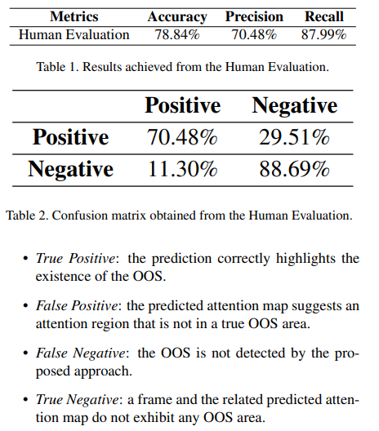
Experimental results prove that the proposed approach is promising since it achieves an Accuracy of 78, 84% and a Recall of 87, 99% which remark that the model is able to detect OOS areas with good performances.
Software implementation like pycharm and Tensorflow gives easy and accurate results for image identification.
Comparative study of Out-of-Stock Detection in Retail Shelf Images Based on Deep Learning:
In addition to causing significant sales losses, missing products on the shelves can damage a company's brand or drive away devoted clients. A two-stage training procedure and a post-processing strategy intended to eliminate erroneous detections are used in Zoran Kalafatic's (2024) innovative deep learning approach-based OOS-detection system.
According to the experimental results, the suggested approach detects entirely empty and frontal OOS instances with 86.3% and 83.7% of the average precision, respectively, outperforming the current DL-based OOS-detection approaches.
Other Studies:
OOS detection is an issue that can be resolved in several ways. Papakiriakopoulos (2009) suggested a rule-based decision support system for automatic OOS detection based on sales and other data as one of the earliest solutions to this issue. A sensor-based approach for identifying OOS’s on store shelves was later put out in a few number of studies.
Bertolini (2013) tracked the quantity of goods in the supermarket shelves using RFID technology. Computer vision-based techniques can examine the state of more products simultaneously, have fewer scaling problems, and are less expensive to integrate into an OOS detection system installed in a supermarket than sensor-based systems (Santra. B etal., 2022), (Mukherjee, 2019).
Object detection models can be trained to directly detect OOS in addition to being used in product detection-based OOS techniques. Semi-supervised DL was employed by Yilmazer and Birant (Yilmazer, R.; Birant, 2021) to locate goods and OOSs in supermarkets. To identify three product classes and two, three distinct one-stage object-detection models were first trained.
OOS classes (almost empty and empty shelves) with the labeled information. Specifically, the models YOLOv3 (Redmon, J.; Farhadi, A. 2020), YOLOv4 (Bochkovskiy, 2020) and RetinaNet(Lin, T.Y.; Goyal, P.; Girshick, R, 2017) were chosen for this purpose. Examining how the size of the training set affected the outcome, the results revealed that performance increased nearly logarithmically as the training set size increased linearly.
Despite the authors' assertion in (Chen, J., 2019) that direct OOS detection with a CNN cannot yield satisfactory results because OOSs vary in size, illumination, and background, the techniques suggested in (Jha, D.; Mahjoubfar, A.; Joshi, A. 2022) demonstrate that such an approach can yield not only satisfactory but also highly accurate results. Nevertheless, none of the post-processing strategies or unique training configurations offered by the suggested approaches for direct OOS detection are able to enhance the outcomes of a simple CNN training process (in Chen, J., 2019), semi-supervised learning failed to do so).
Methodology:
Figure 12 shows the suggested OOS-detection technique. A training section and an inference section are the two primary components of our methodology. To create the following augmented shelf photos, the original shelf images containing OOSs are first subjected to a novel augmentation process appropriate for OOS identification. In order to enlarge itself over adjacent goods, a randomly chosen OOS instance from an initial image is copied and mirrored horizontally, either to the left or right. Two factors make the suggested OOS mirroring enhancement technique appropriate for OOS detection in pictures. First, a real-world scenario where multiple shoppers take items from the same shelf during the workday is realistically depicted by the mirroring approach.
Second, unlike the suggested mirrored augmentation, standard data augmentation methods like image translation and scale shift modify the precise location of OOS instances in photos but leave the instances' shapes unchanged. Extended instances could improve the localization performance of an object-detection model trained on images created by the suggested mirroring strategy.
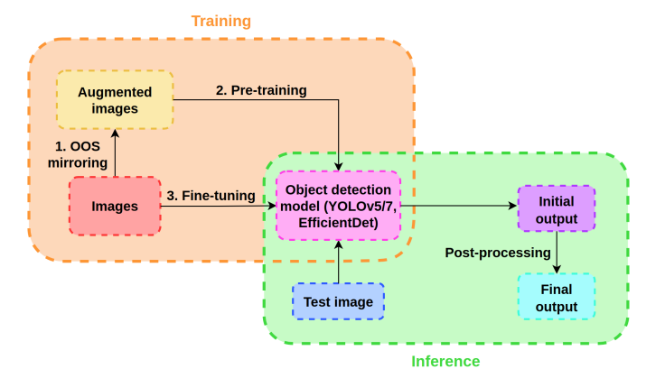
Figure 12. Scheme of the proposed OOS-detection method. The training part and the inference part of the method are marked with orange and green dashed rounded rectangles, respectively.

Result:
The proposed OOS mirroring technique outperformed other data augmentation techniques by at least 1.4%, 1.7%, and 1.8% for the YOLOv5, YOLOv7, and EfficientDet models, respectively.

Conclusion:
The literature review emphasizes how advanced computer vision techniques and autonomous robots are increasingly being used to improve retail shop operations, particularly in the areas of inventory management, product recognition, and out-of-stock (OOS) detection. The drawbacks of traditional manual techniques include human error-related mistakes and the high expenses of labor, shoplifting, and vandalism. An efficient substitute is offered by autonomous systems that are aided by sophisticated machine learning algorithms, computer vision, and deep learning. Visual discrepancies including dim lighting, different perspectives, and overlapping objects on store shelves can be overcome with the help of techniques like Convolutional Neural Networks (CNNs), YOLO-based object recognition, and Swin Transformers.
Research shows that robots like ROCKy, which use Deep Convolutional Neural Networks (DCNNs) to identify out-of-stock (OOS) merchandise, and Ultra-Wideband (UWB) technology, which tracks customer movements and behaviors in real-time, are both effective. Similar approaches have begun to be implemented by retail behemoths like Decathlon and FamilyMart, confirming their effectiveness. Ongoing difficulties, however, include improving detection accuracy in various retail settings and guaranteeing safe navigation in congested areas.
The creation of specific datasets, such SKU-110K and the EgoCart dataset, has improved egocentric vision and item localization applications, which are essential for shelf monitoring and OOS detection. Techniques that use CNNs and fusion classifiers trained on these datasets have shown promise in accurately identifying and resolving OOS problems.
But there are still gaps, especially when it comes to creating reliable, affordable, and real-time monitoring systems that take into consideration consumer safety, collision-free navigation, and effective product recognition in difficult situations.
In conclusion, even though AI-based solutions and autonomous robots have shown notable advancements in inventory control and consumer safety, more study and development are required to completely maximize their application in dynamic retail environments. Future developments in retail automation may be fueled by the integration of these technologies with IoT and the continuous improvement of computer vision algorithms.

References:
- Trung, H.D. (2023). An IoT System Design for Industrial Zone Environmental Monitoring Systems. In: Abraham, A., Hong, TP., Kotecha, K., Ma, K., Manghirmalani Mishra, P., Gandhi, N. (eds) Hybrid Intelligent Systems. HIS 2022. Lecture Notes in Networks and Systems, vol 647. Springer, Cham. https://doi.org/10.1007/978-3-031-27409-1_4
- I. Kalinov et al., "WareVision: CNN Barcode Detection-Based UAV Trajectory Optimization for Autonomous Warehouse Stocktaking," in IEEE Robotics and Automation Letters, vol. 5, no. 4, pp. 6647-6653, Oct. 2020, doi: 10.1109/LRA.2020.3010733. keywords: {Cameras;Drones;Real-time systems;Meters;Robot kinematics;Pallets;Inventory management;computer vision for automation;multi-robot systems;AI-based methods;object detection;segmentation and categorization},
- B. Yao, A. Khosla and L. Fei-Fei, "Combining randomization and discrimination for fine-grained image categorization", Conference on ComputerVision and Pattern Recognition (CVPR), 2011, June.
- J. Deng, J. Krause and L. Fei-Fei, "Fine-grained crowdsourcing for fine-grained recognition", Proceedings of the IEEE Conference on computerVision and Pattern Recognition, pp. 580-587, 2013.
- T. Berg, J. Liu, S. W. Lee, M. L. Alexander, D. W. Jacobs and P. N. Belhumeur, "Birdsnap: Large-scale fine-grained visual categorization of birds", Conference on ComputerVision and Pattern Recognition (CVPR), 2014, June.
- Santra B., Mukherjee D. P. A comprehensive survey on computer vision based approaches for automatic identification of products in retail store. Image and Vision Computing. 2019;86:45–63. [Google Scholar]
- Melek C. G., Sonmez E. B., Albayrak S. A survey of product recognition in shelf images. Proceedings of the 2017 International Conference on Computer Science and Engineering (UBMK); 2017; Antalya, Turkey. pp. 145–150. [Google Scholar]
- Paolanti, M., Sturari, M., Mancini, A., Zingaretti, P. and Frontoni, E., 2017, September. Mobile robot for retail surveying and inventory using visual and textual analysis of monocular pictures based on deep learning. In 2017 European conference on mobile robots (ECMR) (pp. 1-6). IEEE.
- Yedla, S.K.; Manikandan, V.; Panchami, V. Real-time Scene Change Detection with Object Detection for Automated Stock Verification. In Proceedings of the 2020 5th International Conference on Devices, Circuits and Systems (ICDCS), Coimbatore, India, 5–6 March 2020; pp. 157–161. [Google Scholar]
- Remote-Controlled Robot Staff Tested in Japanese Convenience Store. Available online: https://interestingengineering.com/culture/remote-controlled-robot-staff-tested-in-japanese-convenience-store (accessed on 18 March 2023).
- Simbe Robotics Brings Tally to Streamline Decathlon’s Store Experience. Available online: https://www.decathlon.com/blogs/inside-decathlon/simbes-robotic-tally-decathlon (accessed on 18 March 2023).
- Computer vision, 1999. The proceedings of the seventh IEEE international conference on, vol. 2, Ieee (1999), pp. 1150-1157
- International journal of computer vision, 60 (2) (2004), pp. 91-110
- Bay, H., Tuytelaars, T., Van Gool, L. (2006). SURF: Speeded Up Robust Features. In: Leonardis, A., Bischof, H., Pinz, A. (eds) Computer Vision – ECCV 2006. ECCV 2006. Lecture Notes in Computer Science, vol 3951. Springer, Berlin, Heidelberg. https://doi.org/10.1007/11744023_32
- E. Goldman, R. Herzig, A. Eisenschtat, J. Goldberger and T. Hassner, "Precise Detection in Densely Packed Scenes," 2019 IEEE/CVF Conference on Computer Vision and Pattern Recognition (CVPR), Long Beach, CA, USA, 2019, pp. 5222-5231, doi: 10.1109/CVPR.2019.00537. keywords: {Recognition: Detection;Categorization;Retrieval},
- Chen, F. et al. (2022). Unitail: Detecting, Reading, and Matching in Retail Scene. In: Avidan, S., Brostow, G., Cissé, M., Farinella, G.M., Hassner, T. (eds) Computer Vision – ECCV 2022. ECCV 2022. Lecture Notes in Computer Science, vol 13667. Springer, Cham. https://doi.org/10.1007/978-3-031-20071-7_41
- Varadarajan, S., Kant, S., Srivastava, M.M. (2020). Benchmark for Generic Product Detection: A Low Data Baseline for Dense Object Detection. In: Campilho, A., Karray, F., Wang, Z. (eds) Image Analysis and Recognition. ICIAR 2020. Lecture Notes in Computer Science(), vol 12131. Springer, Cham. https://doi.org/10.1007/978-3-030-50347-5_3
- Kant, S., 2020. Learning gaussian maps for dense object detection. arXiv preprint arXiv:2004.11855.
- Pan, X., Ren, Y., Sheng, K., Dong, W., Yuan, H., Guo, X., Ma, C. and Xu, C., 2020. Dynamic refinement network for oriented and densely packed object detection. In Proceedings of the IEEE/CVF conference on computer vision and pattern recognition (pp. 11207-11216).
- Xu, C., Zheng, Y., Zhang, Y., Li, G. and Wang, Y., 2022. A method for detecting objects in dense scenes. Open Computer Science, 12(1), pp.75-82.
- Vasanthi, P. and Mohan, L., 2024. Ensemble of ghost convolution block with nested transformer encoder for dense object recognition. Biomedical Signal Processing and Control, 88, p.105645.
- Lin, T., 2017. Focal Loss for Dense Object Detection. arXiv preprint arXiv:1708.02002.
- Ren, S., He, K., Girshick, R. and Sun, J., 2016. Faster R-CNN: Towards real-time object detection with region proposal networks. IEEE transactions on pattern analysis and machine intelligence, 39(6), pp.1137-1149.
- Redmon, J. and Farhadi, A., 2017. YOLO9000: better, faster, stronger. In Proceedings of the IEEE conference on computer vision and pattern recognition (pp. 7263-7271).
- Ge Z, Liu S, Wang F, et al (2021) Yolox: exceeding yolo series in 2021. arXiv preprint arXiv:2107. 08430
- P. Viola and M. Jones, “Robust real-time object detection”, Intl. J. Computer Vision. vol 57. NO 2. PP. 137–154, 2004
- Rafael C. Gonzalez, Richard Eugene Woods, Digital Image Processing, Pearson Education India, 3rd Edition, 2009
- Paolanti, M., Liciotti, D., Pietrini, R., Mancini, A. and Frontoni, E., 2018. Modelling and forecasting customer navigation in intelligent retail environments. Journal of Intelligent & Robotic Systems, 91, pp.165-180.
- A. Mancini, E. Frontoni, P. Zingaretti, V. Placidi, Smart vision system for shelf analysis in intelligent retail environments, in: ASME 2013 Inter national Design Engineering Technical Conferences and Computers and Information in Engineering Conference, American Society of Mechanical Engineers, Portland, OR, USA, vol. 47, 2013.
- D. Liciotti, M. Paolanti, E. Frontoni, P. Zingaretti, People Detection and Tracking from an RGB-D Camera in Top-View Configuration: Review of Challenges and Applications, in: Lecture Notes in Computer Science (including subseries Lecture Notes in Artificial Intelligence and Lecture Notes in Bioinformatics), vol. 10590 LNCS, 2017, pp. 207–218.
- E. Spera, A. Furnari, S. Battiato, and G. M. Farinella. EgoCart: a benchmark dataset for large-scale indoor imagebased localization in retail stores. IEEE Trans. on Circuits and Systems for Video Technology, 2019.
- G. Agnihotram et al., "Combination of Advanced Robotics and Computer Vision for Shelf Analytics in a Retail Store," 2017 International Conference on Information Technology (ICIT), Bhubaneswar, India, 2017, pp. 119-124, doi: 10.1109/ICIT.2017.13. keywords: {Robots;Histograms;Feature extraction;Machine learning;Support vector machines;Monitoring;Cameras;Deep learning;Double Robot;Machine learning;Planogram Compliance;Product stock out;Shelf space monitoring},
- Z. Liu et al., “Swin transformer: Hierarchical vision transformer using shifted windows,” in Proc. IEEE/CVF Int. Conf. Comput. Vis., 2021, pp. 10012–10022.
- S. Akcay, A. Atapour-Abarghouei, and T. P. Breckon, “GANomaly: Semisupervised anomaly detection via adversarial training,” in Proc. Asian Conf. Comput. Vis., 2018, pp. 622–637.
- C. Baur, B. Wiestler, S. Albarqouni, and N. Navab, “Deep autoencoding models for unsupervised anomaly segmentation in brain MR images,” in Proc. Int. MICCAI Brainlesion Workshop, 2018, pp. 161–169.
- Z. Liu et al., “Swin transformer: Hierarchical vision transformer using shifted windows,” in Proc. IEEE/CVF Int. Conf. Comput. Vis., 2021, pp. 10012–10022.
- : Šiki´c, F.; Kalafati´c, Z.; Subaši´c, M.; Lonˇcari´c, S. Enhanced Out-of-Stock Detection in Retail Shelf Images Based on Deep Learning. Sensors 2024, 24, 693. https:// doi.org/10.3390/s24020693
- Papakiriakopoulos, D.; Pramatari, K.; Doukidis, G. A decision support system for detecting products missing from the shelf based on heuristic rules. Decis. Support Syst. 2009, 46, 685–694. [CrossRef]
- Bertolini, M.; Ferretti, G.; Vignali, G.; Volpi, A. Reducing out of stock, shrinkage and overstock through RFID in the fresh food supply chain: Evidence from an Italian retail pilot. Int. J. RF Technol. 2013, 4, 107–125. [CrossRef]
- Yilmazer, R.; Birant, D. Shelf auditing based on image classification using semi-supervised deep learning to increase on-shelf availability in grocery stores. Sensors 2021, 21, 327. [CrossRef]
- Jha, D.; Mahjoubfar, A.; Joshi, A. Designing an efficient end-to-end machine learning pipeline for real-time empty-shelf detection. arXiv 2022, arXiv:2205.13060. [CrossRef]
- Chen, J.; Wang, S. L.; Lin, H. L. Out-of-stock detection based on deep learning. In Proceedings of the 15th International Conference on Intelligent Computing (ICIC), Nanchang, China, 3–6 August 2019; Springer: Cham, Switzerland, 2019; Volume 11643, pp. 228–237. [CrossRef]
- Santra, B.; Ghosh, U.; Mukherjee, D.P. Graph-based modelling of superpixels for automatic identification of empty shelves in supermarkets. Pattern Recognit. 2022, 127, 108627. [CrossRef]
- Santra, B.; Mukherjee, D.P. A comprehensive survey on computer vision based approaches for automatic identification of products in retail store. Imag. Vis. Comput. 2019, 86, 45–63. [CrossRef]
- Lin, T.Y.; Goyal, P.; Girshick, R.; He, K.; Dollár, P. Focal loss for dense object detection. In Proceedings of the IEEE International Conference on Computer Vision (ICCV), Venice, Italy, 22–29 October 2017; pp. 2980–2988.
- Redmon, J.; Farhadi, A. Yolov3: An incremental improvement. arXiv 2018, arXiv:1804.02767. [CrossRef]
- Bochkovskiy, A.; Wang, C.Y.; Liao, H.Y.M. Yolov4: Optimal speed and accuracy of object detection. arXiv 2020, arXiv:2004.10934. [CrossRef]

